Hiyab Mengisteab
Data Preparation Task 3

Column | Type | Justification
OrderID | Nominal | It's an identifier. No inherent order or ranking.
ProductName | Nominal | Just a label/name of the product. No ranked order.
Quantity | Neither (Numeric) | A numerical (discrete) variable, not categorical.
InvoiceDate | Neither (Datetime) | It's a timestamp, not a category.
UnitPrice | Neither (Numeric) | Continuous numeric value.
TotalCost | Neither (Numeric) | Continuous numeric value.
Country | Nominal | Names of countries, no ranking or order implied.
DiscountApplied | Nominal | Categorical (Yes/No), but not ranked.
OrderPriority | Ordinal | Values like Low, Medium, High have a meaningful order/ranking.
Region | Nominal | Labels like "Northeast", "Southeast" – no natural order.
Segment | Nominal | Categories like Corporate, Consumer – no ranking.
ExpeditedShipping | Nominal | Yes/No variable – categorical without order.
PaymentMethod | Nominal | Categorical (e.g., Credit Card, PayPal) – no order.
CustomerOrderSatisfaction | Ordinal | Values like Dissatisfied, Satisfied, Very Satisfied imply a clear ranking/order.

A. Purpose of the Report

A1. Research Question:
- Which product combinations are frequently bought together in high quantity? This question helps optimize product placement, bundling, and marketing strategies for increased sales.

A2. Goal of Data Analysis:
- To identify high-confidence product associations in high-quantity orders using market basket analysis. This will guide the marketing team on bundling and recommendation strategies based on real purchase patterns.

B. Reason for Market Basket Analysis

B1. Explanation of Market Basket Technique:
Market basket analysis explores the co-occurrence of items within transactions (such as customer orders) to uncover patterns like: “Customers who purchase Product A often also buy Product B.” This analysis helps estimate the likelihood of a product (B) being purchased when another product (A) is bought.
To perform this analysis, we use the Apriori algorithm, a widely-used data mining method for identifying frequent itemsets and generating association rules from transactional data. Apriori is particularly effective in market basket analysis for uncovering relationships between commonly purchased items.
The algorithm works by identifying frequently occurring individual items, then combining them into item pairs and higher-level groupings. It progressively builds larger itemsets by evaluating combinations that meet a minimum support threshold. The core concept of the algorithm is to start by identifying frequent itemsets containing a single item, then recursively build larger itemsets — with two items, three items, and so on — continuing this process until all frequent itemsets of various sizes have been generated.
Along the way, the Apriori algorithm provides key metrics for evaluating the strength of associations:
- Support: How frequently an itemset appears in the dataset.
- Confidence: How often item B is purchased when item A is purchased.
- Lift: The strength of an association compared to random chance (a lift greater than 1 indicates a strong association).

B2. Example Transaction:
- Consider Transaction ID 536852, which includes the following items:
  - POLKADOT RAIN HAT,
  - VINTAGE HEADS AND TAILS CARD GAME,
  - MINI JIGSAW DOLLY GIRL,
  - MINI JIGSAW SPACEBOY,
  - PICTURE DOMINOES,
  - CHARLOTTE BAG DOLLY GIRL DESIGN.
- From this data, we can extract association rules such as: If a customer purchases MINI JIGSAW DOLLY GIRL, they are likely to also purchase CHARLOTTE BAG DOLLY GIRL DESIGN.

B3. Key Assumption:
The core assumption of market basket analysis is that products purchased together once are likely to be purchased together again. This helps identify meaningful product relationships and informs cross-selling or bundling strategies.

C. Data Preparation for Analysis

C1a. Select Variables
- Nominal Variables:
  - Segment
  - Region
- Ordinal Variables (custom order defined):
  - OrderPriority
  - CustomerOrderSatisfaction

C1b. Encoding Steps
Data Prep
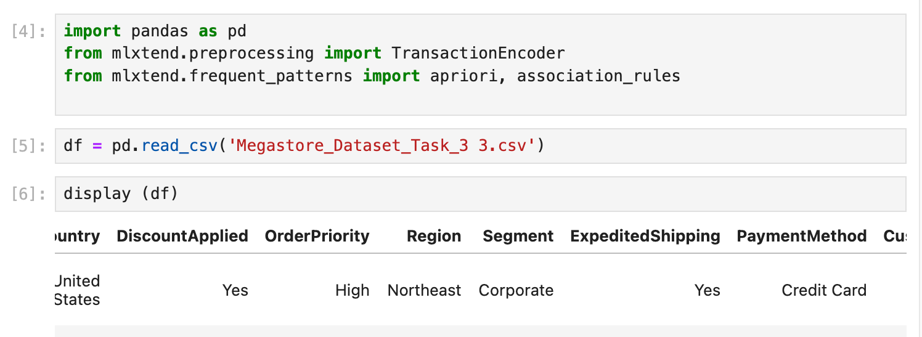
- Ordinal encoding for ordinal variables:
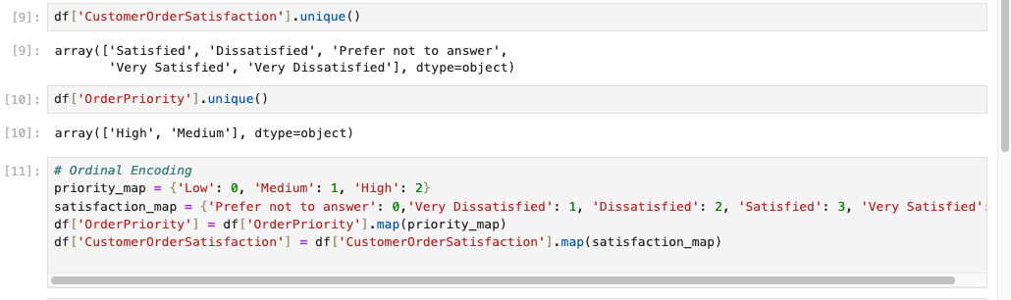
- One Hot Encoding

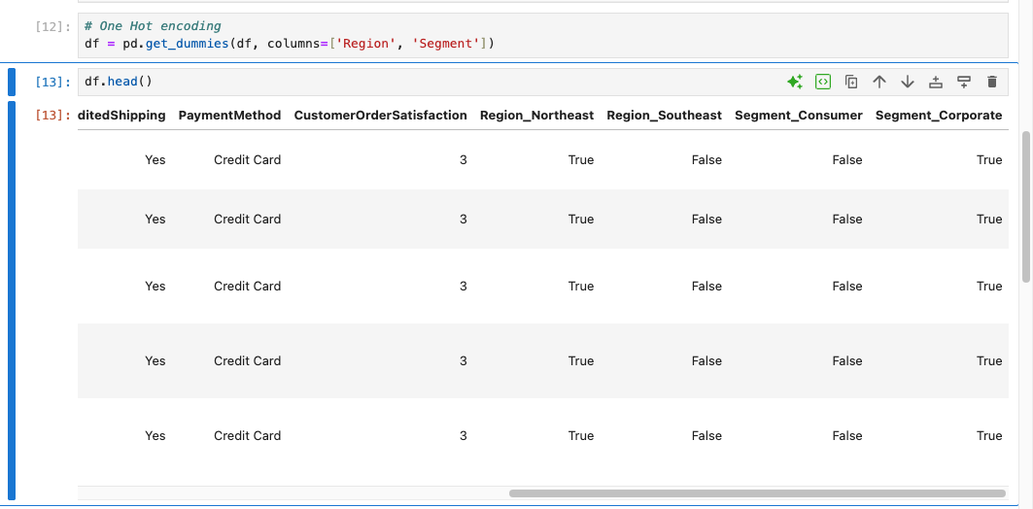

C1c. Transactionalizing
- Transactionalizing ensures Apriori can analyze co-occurrences of items within the same order. (Please note that I tried to set it as 0s and 1s, but while creating the rule it was giving me issues and to fix the error, it was recommended to use Boolean values, which is why it’s True/False values)
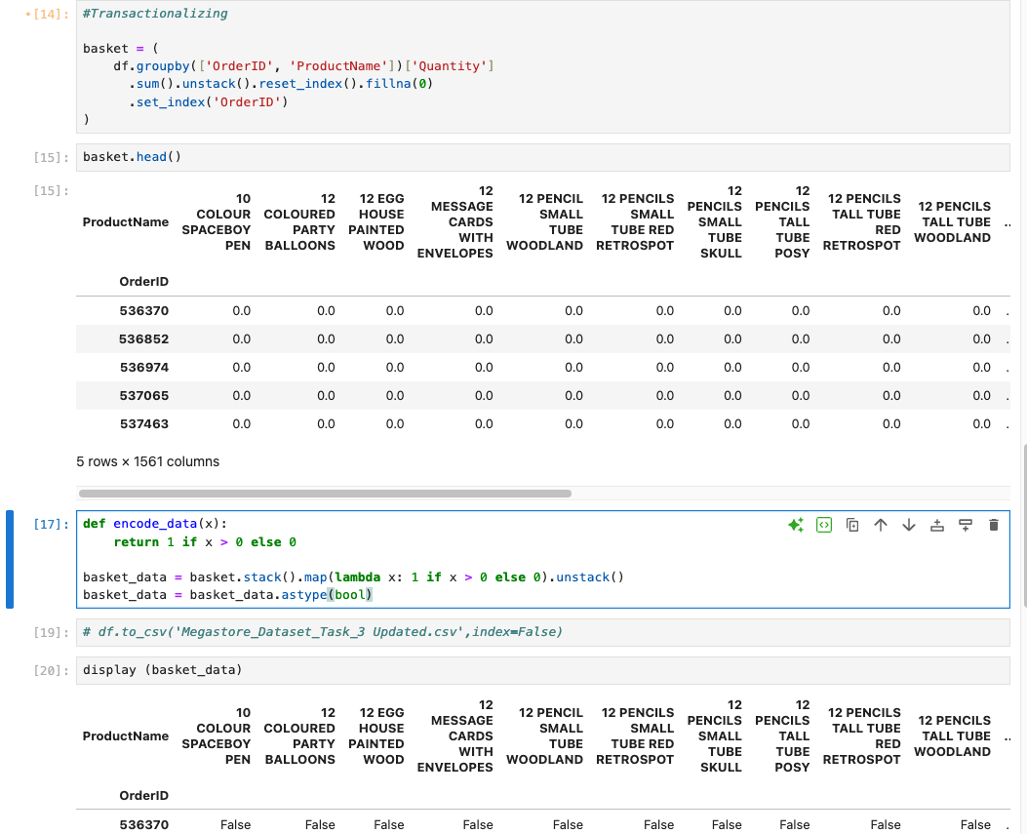

C1c. Steps Explained
- Step 1: I began by reviewing the dataset and identifying which attributes were nominal and which were ordinal. I then selected two attributes from each category for processing.
- Step 2: Using Pandas, I read the CSV file, cleaned data and began encoding the selected attributes. For the ordinal attributes, I first examined their unique values, then created a code to map them to numerical values to reflect their order. I updated the original DataFrame with these encoded values. For the nominal attributes, I used pd.get_dummies() to apply one-hot encoding.
- Step 3: To prepare the data for the Apriori algorithm, I created a basket format by grouping the data by OrderID and separated it by ProductName. I then aggregated the data by summing the Quantity of each product per order. To convert this into a Boolean format required by Apriori, I defined a function that mapped all quantities to 1 (if purchased) or 0 (if not). I applied this function using lambda and converted the final values to Boolean (True for 1, False for 0). This transformation ensured the data was in the correct format for the Apriori analysis.

C2. Cleaned Dataset
- CSV file attached

C3. Apriori Code Execution

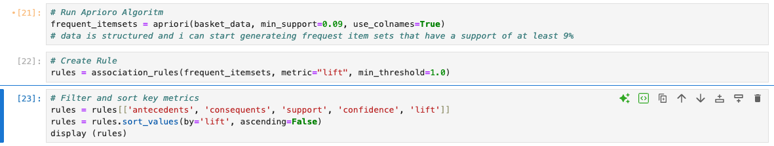

C4. Example Output Values

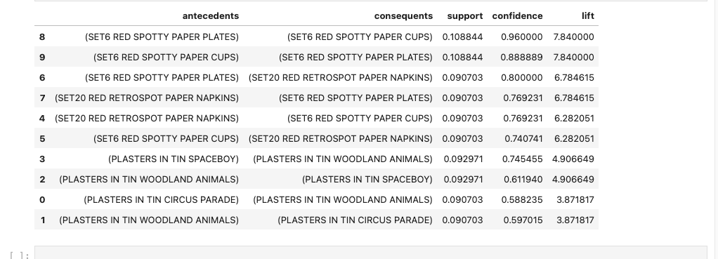

C5. Top 3 Rules Explanation

Interpretation of Top 3 Rules:
Rule 1 | Antecedent: (SET6 RED SPOTTY PAPER PLATES)  Consequent: (SET6 RED SPOTTY PAPER CUPS) | This is a very strong association. Customers who buy the Red Spotty Plates almost always buy the matching Red Spotty Cups. The high lift shows this is far above random chance — likely part of a themed product set or bundle.
Rule 2 | Antecedent: (SET6 RED SPOTTY PAPER CUPS)  Consequent: (SET6 RED SPOTTY PAPER PLATES) | Customers who buy the cups often also buy the plates (88.8% of the time). Together, these two rules suggest a strong two-way bundle pattern, ideal for marketing/promotions.
Rule 3 | Antecedent: ((SET6 RED SPOTTY PAPER PLATES))  Consequent: (SET20 RED RETROSPOT PAPER NAPKINS) | Customers who buy the red spotty paper plates are also highly likely to buy the red retrospot paper napkins. With a lift over 6.78, this rule suggests strong cross-product appeal — likely due to customers buying multiple items for a party in a single order.

D. Summary of Data Analysis

D1. Significance of Metrics
- Support reflects how frequently the item combination appears in all transactions. A higher support value means the products are commonly purchased together.
- Confidence represents the likelihood that the consequent item is bought when the antecedent item is purchased. It indicates the reliability of the rule.
- Lift measures the strength of the association compared to random chance. A lift greater than 1 suggests a strong and meaningful relationship between the items.

D2. Practical Significance
- Product bundles can be created. Store layout or online suggestions can be optimized. And promotional offers can be targeted toward known pairs.

D3. Recommended Action
- Implement combo discounts and cross-selling strategies for frequently paired products. The business should also consider restocking items that are often purchased together. Based on the analysis, party-related products are typically bought at the same time and would benefit from being offered as a bundled discount.
Reference:
- External resources not used in this submission

